# Lab2

**Title: Data Manipulation Language (DML)**

**Objective:**  
To practice and implement Data Manipulation Language commands.

**Description**

This lab focuses on core DML operations using SQL, including inserting, updating, selecting, and deleting data. Students will create an **employee** table and perform practical tasks like bulk record insertion, conditional updates, and filtered queries.

**Questions:**

Create a database Lab2 and a table employee with the following structure:

| **Column Name** | **Data Type** |
| --- | --- |
| E_ID | INT |
| E_NAME | VARCHAR(20) |
| E_JOB | VARCHAR(20) |
| E_SALARY | INT |

**SQL Queries**

**1. Create Database and Table**

CREATE DATABASE Lab2;

USE Lab2;

CREATE TABLE employee (

    E_ID INT,

    E_NAME VARCHAR(20),

    E_JOB VARCHAR(20),

    E_SALARY INT

);

**Output:**

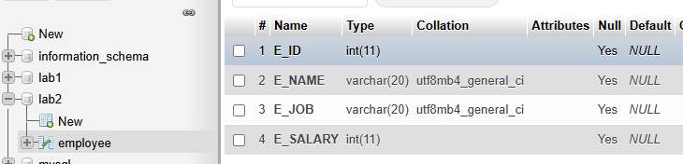

**2. Insert a single record in the employee table**

**SQL Queries**

INSERT INTO employee (E_ID, E_NAME, E_JOB, E_SALARY)

VALUES (1, 'Santosh', 'Programmer', 30000);

**Output:**  


**3. Insert more than one record in the employee table using a single insert command.**

**SQL Queries**

INSERT INTO employee (E_ID, E_NAME, E_JOB, E_SALARY)

VALUES

    (2, 'Surya', 'Designer', 22000),

    (3, 'Phura', 'Analyst', 28000);

**Output:**  
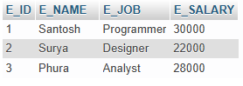

**4. Update the employee table to set salary of all employees to Rs. 25,000 who work as programmer.**

**SQL Queries**

UPDATE employee

SET E_SALARY = 25000

WHERE E_JOB = 'Programmer';

**Output:**  
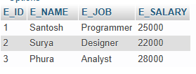

**5. Select all information from the employee table.**

**SQL Queries**

SELECT * FROM employee;

**Output:**

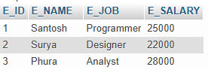

**6. Select employee name (e_name) and job (e_job) from the employee table.**

**SQL Queries**

SELECT E_NAME, E_JOB FROM employee;

**Output:**

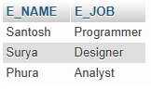

**7. Delete employees working as designer.**

**SQL Queries**

DELETE FROM employee

WHERE E_JOB = 'Designer';

**Output:**  
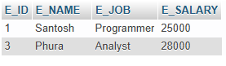

**8. Display only employees who work as analyst.**

**SQL Queries**

SELECT * FROM employee

WHERE E_JOB = 'Analyst';

**Output:**



**9. Display employee job (e_job) from the table while avoiding duplicate values.**

**SQL Queries**

SELECT DISTINCT E_JOB FROM employee;

**Output:**

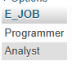

**10. Display employee name (e_name) and job (e_job) for employees with a salary ≥ Rs. 20,000.**

**SQL Queries**

SELECT E_NAME, E_JOB

FROM employee

WHERE E_SALARY >= 20000;

**Output:**

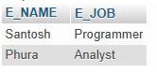

**Appendix: Final Table State**

**SQL Queries**

SELECT * FROM employee;

**Output:**

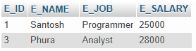

**Conclusion**

This lab successfully demonstrated key DML operations for manipulating database records, including inserting, updating, querying, and deleting data. The exercises provide a strong foundation for real-world database administration and data-driven application development.